Shrinkage correlation: EURUSD and USDCAD
Method 08 / eight-major panel / delta = 0.2 and Ledoit-Wolf / Alpari D1 full available history

Study setup
Logical pair: EURUSD , USDCAD
Broker symbols: EURUSD_i , USDCAD_i
Snapshot: 2026-11-03_majors_alpari_D1
Timeframe: D1
Common eight-major panel window: 1999-01-06 to 2026-11-02 (UTC bar dates)
Panel matched return count n: 7127
Dropped unfinished last bar dated 2026-11-03 UTC after a tick-volume check against the prior complete day.
Fixed shrinkage: delta=0.2, mu=3.9170889e-05 (mean of diag(S))
Ledoit-Wolf estimated delta: 0.0042157642
Panel symbols: EURUSD, GBPUSD, AUDUSD, NZDUSD, USDJPY, USDCHF, USDCAD, EURGBP
Complete matched rows (Excel): EURUSD-USDCAD_Shrinkage_D1.xlsx
Complete matched rows (HTML table): EURUSD-USDCAD_Shrinkage_D1_data.html

Method carried forward
Shrinkage blends the sample covariance matrix S of matched daily log returns of close, ln(close_t / close_t-1), toward a simple target, then converts the shrunk covariance into correlations. Quotes are not inverted. This experiment builds one common calendar across all eight majors, forms S with the unbiased n-1 divisor, then reports two shrinkage specs: fixed delta = 0.2 with mu equal to the average sample variance (mu * I target), and sklearn Ledoit-Wolf with its estimated delta. Pair reports pull rho_ij from those panel matrices. Same-panel Pearson r is a side check only. Shrinkage improves conditioning; it is not a cause, not a lead, and not a trading signal.

Results
pearson_r | rho_02 | rho_LW | rho_02_minus_r | rho_LW_minus_r | delta_LW
-0.458052 | -0.344465 | -0.455504 | 0.113586 | 0.002548 | 0.00421576

Conclusion
Over the common 7127-day eight-major panel for EURUSD and USDCAD (broker quote directions unchanged), fixed-delta shrinkage correlation at delta=0.2 is -0.3445 (negative, weak linear link in this sample). Ledoit-Wolf rho is -0.4555 with estimated delta=0.004216. Same-panel Pearson r is -0.4581 (rho_02 minus r = 0.1136; rho_LW minus r = 0.0025). This does not establish cause, lead-lag, or a lasting trading rule.

Charts
Daily closes
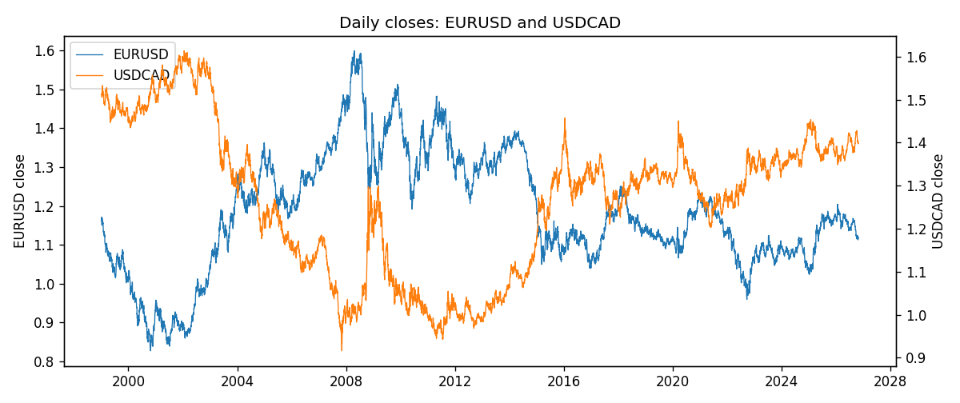
Daily log returns
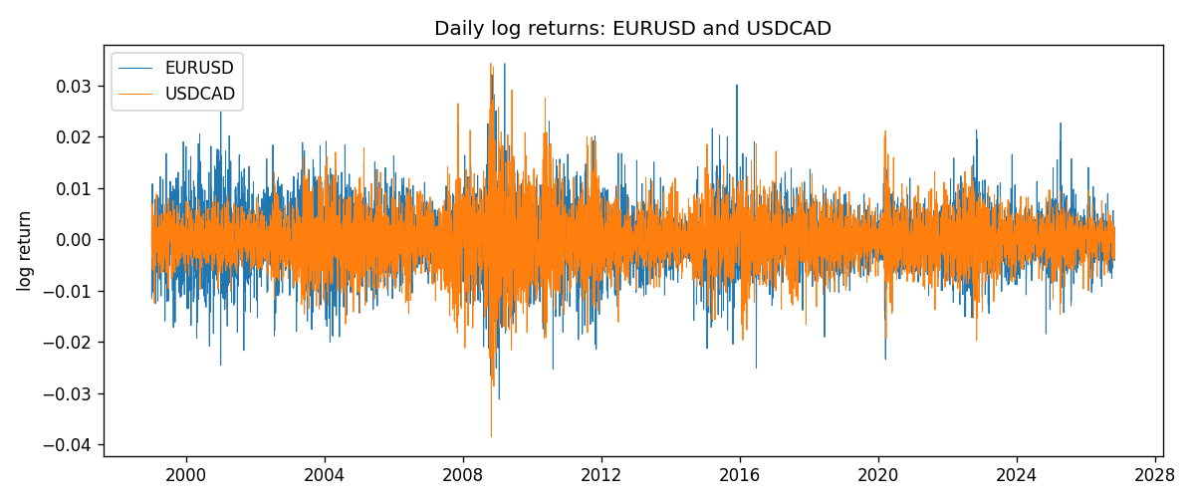
Log-return scatter
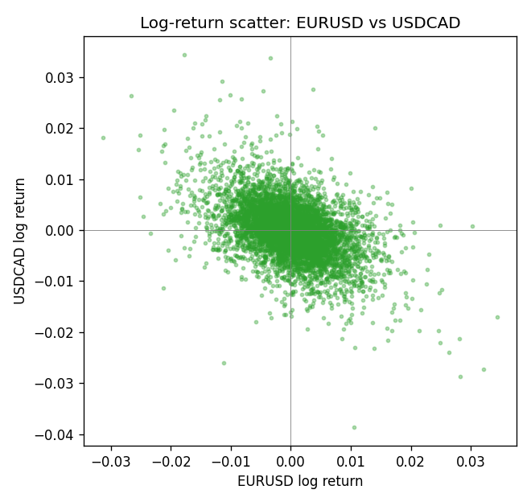

Data report
Every panel row for this pair slice is stored in the sibling Excel workbook named EURUSD-USDCAD_Shrinkage_D1.xlsx. Full-panel covariance and correlation matrices are saved once under outputs/ as CSV files. Embedding all rows as a Word table is impractical at this length; the Word file holds the column list, column summaries, and the first and last 15 matched rows.
Columns: time, EURUSD_open, EURUSD_high, EURUSD_low, EURUSD_close, EURUSD_tick_volume, EURUSD_spread, EURUSD_real_volume, EURUSD_log_return, USDCAD_open, USDCAD_high, USDCAD_low, USDCAD_close, USDCAD_tick_volume, USDCAD_spread, USDCAD_real_volume, USDCAD_log_return
Column summaries (panel rows)
column | count | mean | std | min | 25% | 50% | 75% | max
EURUSD_open | 7127 | 1.1819407 | 0.15065555 | 0.8272 | 1.086455 | 1.16615 | 1.294285 | 1.5995
EURUSD_high | 7127 | 1.1870746 | 0.15125674 | 0.8326 | 1.09055 | 1.17128 | 1.29974 | 1.6038
EURUSD_low | 7127 | 1.1769341 | 0.14996546 | 0.8227 | 1.082375 | 1.16257 | 1.288915 | 1.5865
EURUSD_close | 7127 | 1.1819858 | 0.15061943 | 0.8267 | 1.08652 | 1.16617 | 1.294345 | 1.5997
EURUSD_tick_volume | 7127 | 103994.86 | 174033.72 | 469 | 9542.5 | 53148 | 99923.5 | 1471626
EURUSD_spread | 7127 | 19.176652 | 16.472988 | 0 | 8 | 12 | 20 | 50
EURUSD_real_volume | 7127 | 4.0656436e+10 | 1.6756658e+11 | 0 | 0 | 0 | 0 | 3.6149665e+12
EURUSD_log_return | 7127 | -3.8e-07 | 0.00580028 | -0.03123819 | -0.00324243 | 8.31e-06 | 0.00325629 | 0.03433183
USDCAD_open | 7127 | 1.2660158 | 0.16869092 | 0.9168 | 1.11698 | 1.29814 | 1.371685 | 1.6183
USDCAD_high | 7127 | 1.2709144 | 0.16864061 | 0.9336 | 1.122275 | 1.30368 | 1.37575 | 1.619
USDCAD_low | 7127 | 1.2614634 | 0.1687284 | 0.9056 | 1.112315 | 1.29315 | 1.36729 | 1.6102
USDCAD_close | 7127 | 1.2660395 | 0.16866578 | 0.916 | 1.116855 | 1.298 | 1.371955 | 1.6137
USDCAD_tick_volume | 7127 | 81672.889 | 147760.33 | 56 | 5669.5 | 41299 | 71973 | 1410818
USDCAD_spread | 7127 | 23.249895 | 18.19595 | 0 | 9 | 17 | 40 | 60
USDCAD_real_volume | 7127 | 1.8530805e+10 | 9.7086285e+10 | 0 | 0 | 0 | 0 | 2.5751613e+12
USDCAD_log_return | 7127 | -7.67e-06 | 0.00514753 | -0.03859748 | -0.0028338 | 5.597e-05 | 0.00272861 | 0.03436319
First 15 panel rows (selected columns)
time | EURUSD_close | USDCAD_close | EURUSD_log_return | USDCAD_log_return
1999-01-06 | 1.1623 | 1.5118 | -0.011547966 | -0.0003306769
1999-01-07 | 1.1712 | 1.5141 | 0.0076280636 | 0.0015202092
1999-01-08 | 1.1585 | 1.511 | -0.010902799 | -0.0020495197
1999-01-11 | 1.1503 | 1.5057 | -0.007103287 | -0.0035137769
1999-01-12 | 1.1555 | 1.5157 | 0.0045103728 | 0.0066194721
1999-01-13 | 1.1681 | 1.5226 | 0.010845346 | 0.0045420214
1999-01-14 | 1.1681 | 1.5332 | 0 | 0.0069376546
1999-01-15 | 1.1563 | 1.5245 | -0.010153245 | -0.0056905671
1999-01-18 | 1.1605 | 1.526 | 0.0036256946 | 0.00098344542
1999-01-19 | 1.1603 | 1.5302 | -0.00017235436 | 0.002748513
1999-01-20 | 1.1566 | 1.5211 | -0.0031939256 | -0.0059646885
1999-01-21 | 1.1601 | 1.5146 | 0.0030215416 | -0.0042823796
1999-01-22 | 1.1587 | 1.5184 | -0.0012075213 | 0.0025057712
1999-01-25 | 1.1552 | 1.5197 | -0.0030251979 | 0.00085579808
1999-01-26 | 1.1562 | 1.52 | 0.00086527651 | 0.0001973879
Last 15 panel rows (selected columns)
time | EURUSD_close | USDCAD_close | EURUSD_log_return | USDCAD_log_return
2026-10-13 | 1.11965 | 1.4214 | 0.0037402957 | -0.0046395653
2026-10-14 | 1.11545 | 1.42356 | -0.0037582255 | 0.0015184751
2026-10-15 | 1.12172 | 1.41843 | 0.0056053107 | -0.0036101503
2026-10-16 | 1.12371 | 1.41357 | 0.0017724895 | -0.0034322068
2026-10-19 | 1.12086 | 1.41091 | -0.0025394633 | -0.0018835331
2026-10-20 | 1.12354 | 1.40569 | 0.0023881672 | -0.0037066008
2026-10-21 | 1.12318 | 1.4045 | -0.00032046717 | -0.00084691787
2026-10-22 | 1.12139 | 1.40081 | -0.0015949606 | -0.0026307268
2026-10-23 | 1.11989 | 1.40085 | -0.001338521 | 2.85545e-05
2026-10-26 | 1.11735 | 1.40093 | -0.0022706559 | 5.7106554e-05
2026-10-27 | 1.11272 | 1.40449 | -0.004152342 | 0.0025379458
2026-10-28 | 1.1152 | 1.39911 | 0.0022262927 | -0.0038379274
2026-10-29 | 1.11772 | 1.39895 | 0.0022571351 | -0.00011436495
2026-10-30 | 1.11644 | 1.39751 | -0.0011458446 | -0.0010298736
2026-11-02 | 1.11881 | 1.39837 | 0.002120569 | 0.00061519094

